**DAILY ONLINE ACTIVITIES SUMMARY**

|  |  |  |  |  |  |  |  |  |
| --- | --- | --- | --- | --- | --- | --- | --- | --- |
| **Date:** | 22-05-2020 | | | | | **Name:** | K S Prajwal | |
| **Sem & Sec** | Vi A sec | | | | | **USN:** | 4AL18CS032 | |
| **Online Test Summary** | | | | | | | | |
| **Subject** | | Operating system | | | | | | |
| **Max. Marks** | | 30 | | **Score** | | | 23 | |
| **Certification Course Summary** | | | | | | | | |
| **Course** | Computer Vision Essentials | | | | | | | |
| **Certificate Provider** | | | Greatlearning.in | | **Duration** | | | **2 hr** |
| **Coding Challenges** | | | | | | | | |
| **Problem Statement: :** 1. Stack operation using SLL  2. Round robin type of process scheduling | | | | | | | | |
| **Status:** completed | | | | | | | | |
| **Uploaded the report in Github** | | | | | yes | | | |
| **If yes Repository name** | | | | | <https://github.com/alvas-education-foundation/KS_Prajwal> | | | |
| **Uploaded the report in slack** | | | | | yes | | | |

Online Test Details: (Attach the snapshot and briefly write the report for the same)

Certification Course Details: (Attach the snapshot and briefly write the report for the same)

Coding Challenges Details: (Attach the snapshot and briefly write the report for the same)

**Online Test Details**: The online test was from module 1 which was about the introduction to operating systems, system structures, different operating system services and process management. There were 30 questions and the duration were 40 minutes. The questions were optimal and were easy. The score that I got in the test is 23/30.

**Snapshot**:

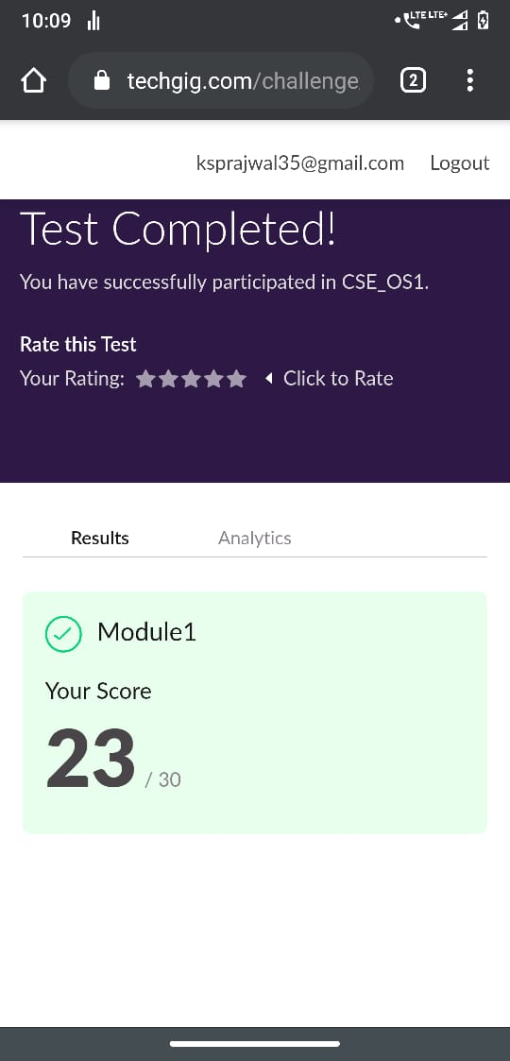

Snapshot of certification course:

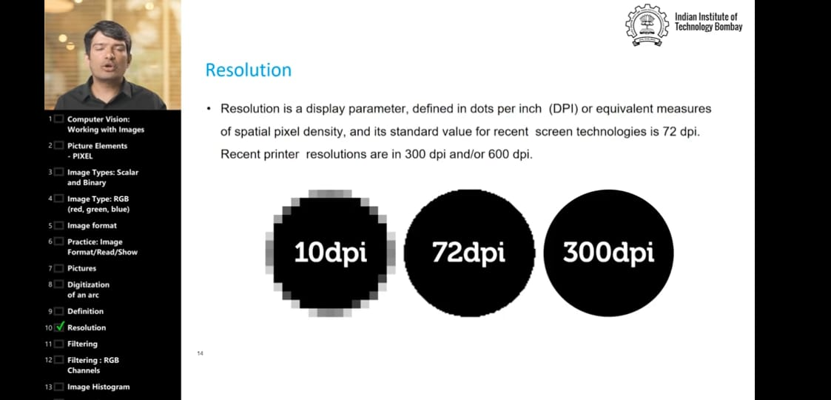

Today the video was about the adding the image saving the image, using filters on image. They explained about the DPI resolution pixels in the image etc. it even included about the Gray scale , RGB etc.

**Online coding:**

Problem 1: (using C language) Do the basic operations on a stack where stack is implemented using singly linked list

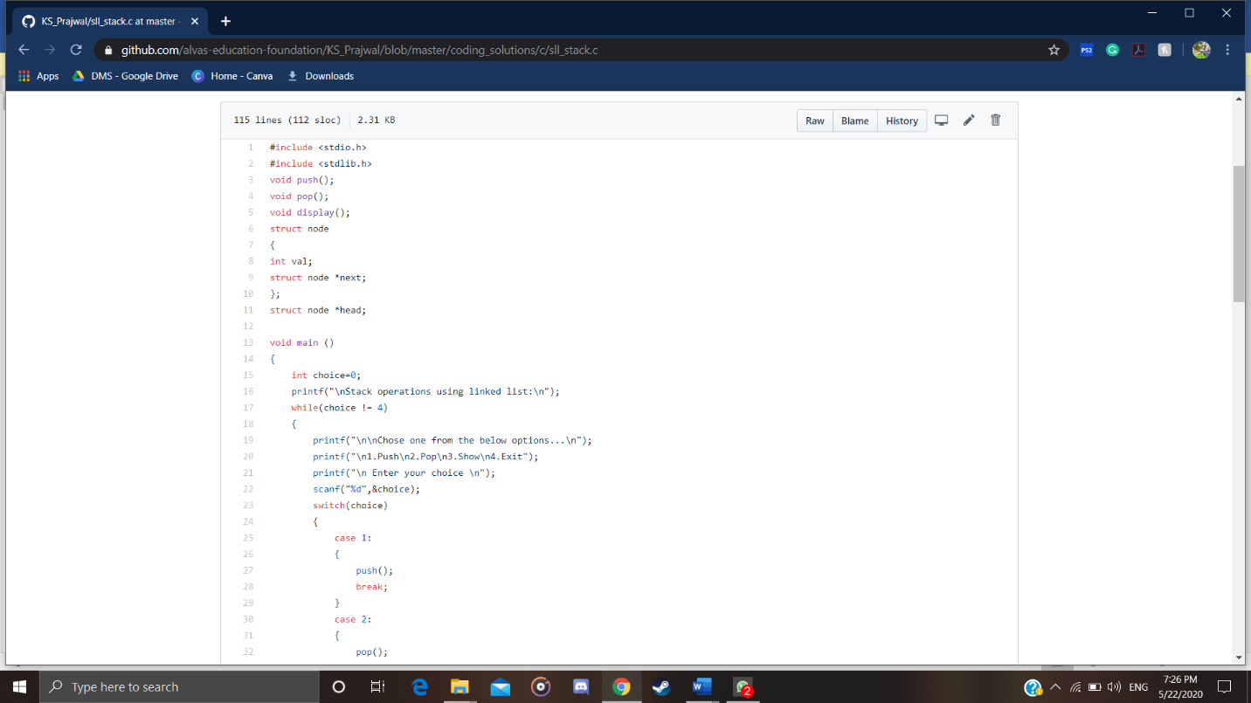

Problem 2: (Using C) Perform round robin type of process scheduling

